**TECHNOLOGICAL INSTITUTE OF THE PHILIPPINES**

**Quezon City**

COLLEGE OF INFORMATION TECHNOLOGY EDUCATION

Computer Science Department

CS 307 – Thesis 1

**Pneumothorax Disease Detection on Chest X-Rays**

**Using Image Segmentation**

Gabriel Joshua Miguel

Ria Marie Toledo

Michael Joe Refuerzo

CS 307 Thesis 1

Jasper S. Agustin

Adviser

May 2019

**Chapter 1**

**INTRODUCTION**

Chest radiography is the foremost well-known kind of imaging examination of the planet, with more than 2 billion procedures played out each year [1]. This procedure is fundamental for screening, examination, and the board of thoracic afflictions, an expansive number of which are among the most sources of mortality generally [2]. A computer framework system to translate chest radiographs as satisfactorily as practicing radiologists seem in this way allow significant advantage in various clinical settings, from moving forward work prepare prioritization and clinical choice offer assistance to gigantic scale screening and around the world masses well being exercises.

Pneumothorax is usually diagnosed by a radiologist on a chest x-ray. In some cases, a computerized tomography (CT) scan may be needed to provide more-detailed images. Ultrasound imaging also may be used to identify a pneumothorax, and can sometimes be very difficult to confirm is a condition that is responsible for making people suddenly gasp for air, and feel helplessly breathless for no apparent reason.It can result from a variety of etiologies including chest trauma, pulmonary disease, and spontaneously. On some occasions, pneumothorax can be life threatening and is considered an emergency in intensive care, requiring prompt recognition and intervention [12].

Deep learning is currently the method of choice for numerous task in computer vision such as image classification. With the availability of large datasets and advance computer resources, deep learning achieved a performance on par with the medical professionals in tasks such as diabetic retinopathy detection[3] and skin cancer classification [4].

**Background of the Study**

With more than 2 billion X-Ray exams done annually, X-Ray is often the hospital’s first impression of a patient. Just like first impression with people, the first image helps set the path going forward. “When an X-Ray is taken on a patient, especially a patient who’s suffering from an emergent condition or a potentially life.-threatening condition, the time that it takes to process, have someone read that and have the image actually come into a queue is a really important time period where minutes and hours matter.” said Dr. Rachael Callcut, Associate Professor of Surgery at the University of California, San Francisco (UCSF) Medical Center and Director of Data Science for the Center for Digital Health Innovation.

**Objectives**

The study aims to effectively diagnose if the patient has Pneumothorax using Image Segmentation. Specifically the study aims to:

* Develop a model to identify and segment pneumothorax from a set of chest radiographic images

**Significance of the Study**

The study of the development of the proposed work will benefit the following:

**Radiologist**. Medical doctors that specialize in diagnosing and treating injuries and diseases using medical imaging (radiology) procedures (exams/tests) such as X-rays, computed tomography (CT), magnetic resonance imaging (MRI), nuclear medicine, positron emission tomography (PET) and ultrasound.

**Patient.** An individual who is receiving needed professional services that are directed by a licensed practitioner of the healing arts toward maintenance, improvement or protection of health or lessening of illness, disability or pain.

**Future Researchers**. The proposed study will be a useful reference for the researchers who would plan to make a study relative to this research in the future.

**Hospital.** A health care institution providing patient treatment with specialized medical and nursing staff and medical equipment.

**Scope and Delimitation**

The study involves the development of Deep Learning model that will be able to identify pneumothorax disease in chest x-rays.

**Limitations**

The model cannot identify what types of pneumothorax the patient have. This model can be used by doctors only.

**Conceptual Framework**

Below is an Input Process Output (IPO) diagram that lists the inputs and outputs of each individual process.

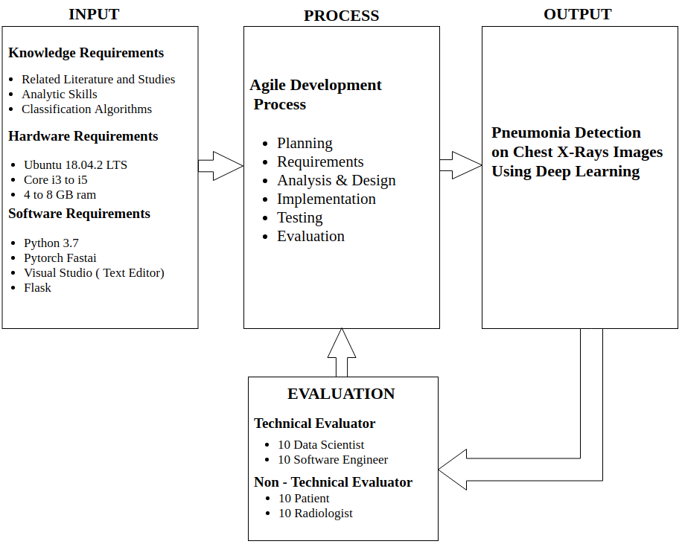

**Figure 3. Conceptual Framework**

The diagram shows the input, process then eventually the output. In the input part we has three requirements. The researches will plan and gather all the requirements necessary for them to analyze and predict the data. After gathering the researchers will start to train the data.

**System Architecture.** Itshows the structure and behavior of the system being developed. The three-tier application is used.

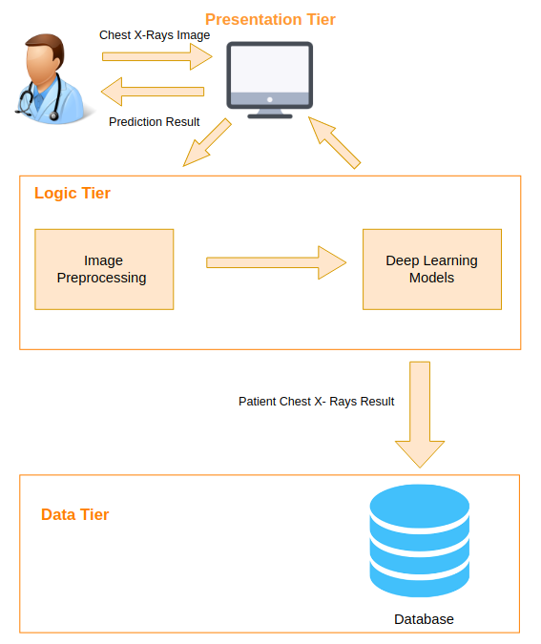

**Figure 4. System Architecture**

**Presentation Tier.**

**Logic Tier.**

**Data Tier.**

**Definition of Terms**

**Patient.**

**Algorithm.** It is a step by step instructions and is need to be done in order to accomplish task.

**Radiologist.**

**Website**. It is a collection of publicly accessible, interlinked Web pages that share a single domain name.

**Chapter 2**

**THEORETICAL FRAMEWORK**

This chapter focuses on presenting and discussing other existing concepts and theories that are relevant to the study. These studies can further validate the study’s background and provide supplementary information about existing studies and theories that can be related to the study designed. The technical terms are also defined at the end of this chapter to help elaborate the study. These terms are defined conforming to the study’s definition.

**Chapter 3**

**METHODOLOGY**

The Chapter focuses on discussing the research design to be used in developing the application. This chapter also includes the different diagrams to present the workflow of the system and the software process model.

**Project Design**

The project design includes the three (3) diagrams to describe the system which includes Use Case Diagram, Context Diagram and Algorithm Design.

**Project Development**

In this section is the discussion about the project development of the system which includes the data gathering procedures to be conducted, testing and operation procedures, and the software model to be used.

**Software Process Model**

The software process model used in the study is Agile Development Model. Agile Development model is an approach to software development under which requirements and solutions evolve through the collaborative of self-organizing and cross-functional.

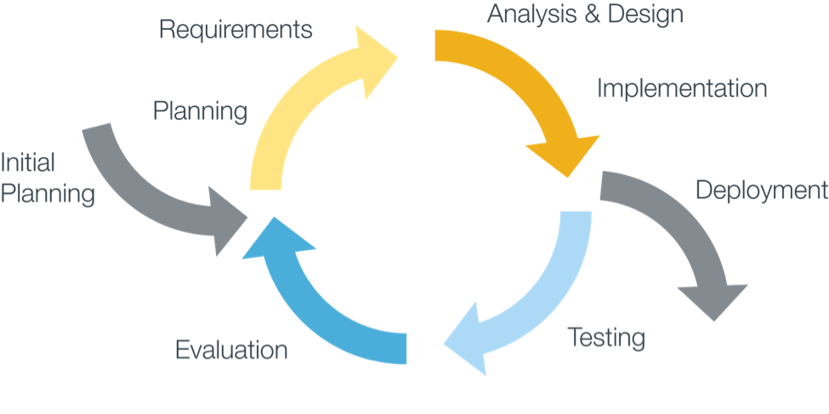

**Figure 8. Agile Development Model**

**1stIteration:**

**Planning.** The researchers will analyze the gathered information, data and understand the flow of the system.

**Implementation.** The researchers will implement all the features, functionalities needs for diagnosing pneumonia.

**Testing.** The researcher will conduct testing to see if the system meet the all requirements needed for diagnosing pneumonia.

**2ndIteration:**

**Planning.** The researchers will improve the features, functionalities and design of the system.

**Implementation.** The researchers will implement the improve features, functionalities and design

**Testing.** The researcher will conducting testing again to see the improvement of the system

**3rdIteration:**

**Planning.** The different algorithms were compared to identify the best accuracy level in terms of prediction

**Implementation.** The researchers will further implement the best algorithm for the system.

**Testing.** The developers will perform evaluation and testing to have a better accuracy in doing the prediction.

**Evaluation.** The researchers conducted surveys for the technical users and non-technical users.

**[1]** [**https://linkinghub.elsevier.com/retrieve/pii/S0012369212600968**](https://linkinghub.elsevier.com/retrieve/pii/S0012369212600968)

**[2]** [**https://journals.plos.org/plosmedicine/article?id=10.1371/journal.pmed.0030442**](https://journals.plos.org/plosmedicine/article?id=10.1371/journal.pmed.0030442)

**[3]https://journals.plos.org/plosmedicine/article?id=10.1371/journal.pmed.1002686#**

**[4] https://www.nature.com/articles/nature21056**

**[5] https://jamanetwork.com/journals/jama/fullarticle/2665774**

**[6] https://insights.ovid.com/crossref?an=00004424-201705000-0000**

**[8]** [**https://journals.plos.org/plosmedicine/article?id=10.1371/journal.pmed.1002686#**](https://journals.plos.org/plosmedicine/article?id=10.1371/journal.pmed.1002686#)

**[9]** [**https://pubs.rsna.org/doi/10.1148/radiol.2017162326**](https://pubs.rsna.org/doi/10.1148/radiol.2017162326)

**[10]** [**https://doi.org/10.1109/TMI.2016.2536809**](https://doi.org/10.1109/TMI.2016.2536809)

**[11]**